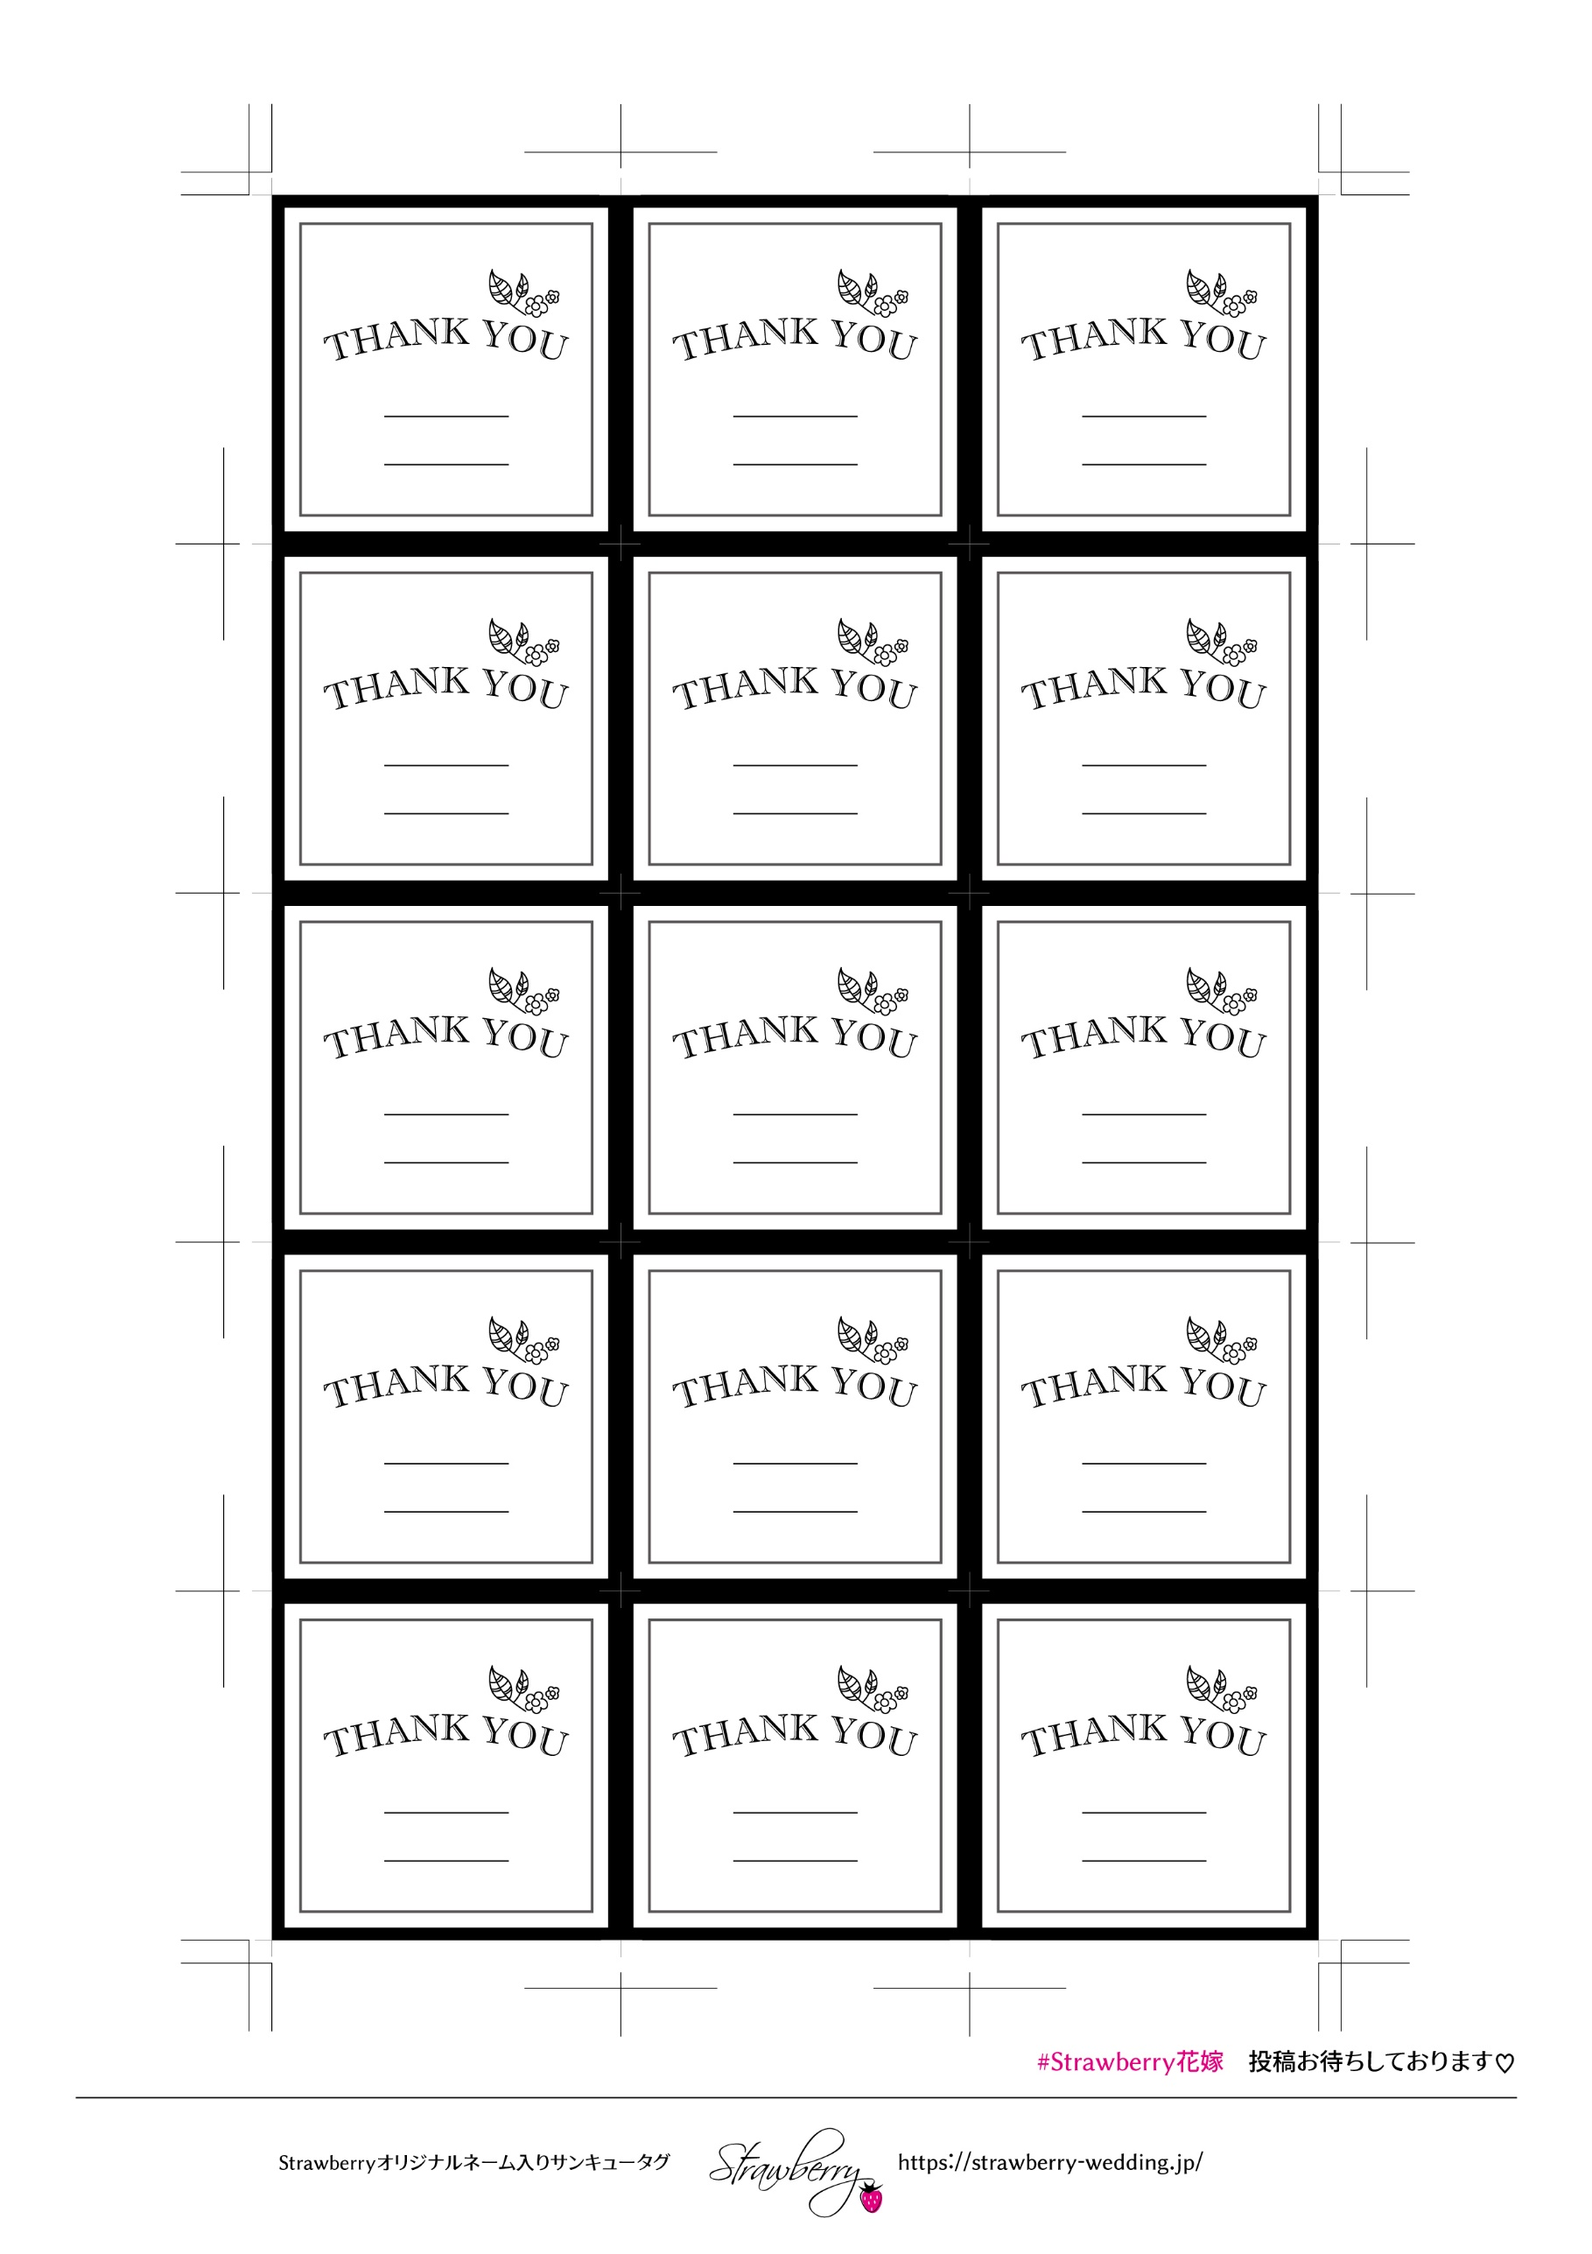

T&H

T&H

T&H

T&H

T&H

T&H

T&H

T&H

T&H

T&H

T&H

T&H

T&H

T&H

T&H