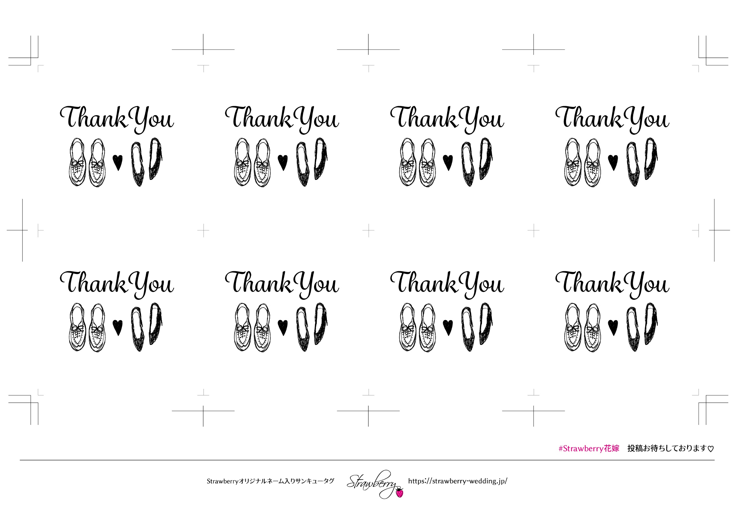

Taro&hanako

2020.may.22

Taro&hanako

2020.may.22

Taro&hanako

2020.may.22

Taro&hanako

2020.may.22

Taro&hanako

2020.may.22

Taro&hanako

2020.may.22

Taro&hanako

2020.may.22

Taro&hanako

2020.may.22

Taro&hanako

2020.may.22

Taro&hanako

2020.may.22

Taro&hanako

2020.may.22

Taro&hanako

2020.may.22

Taro&hanako

2020.may.22

Taro&hanako

2020.may.22

Taro&hanako

2020.may.22

Taro&hanako

2020.may.22